

**INTERPRETING DOCTOR’S PRESCRIPTION**

*EPICS PROJECT REPORT submitted in partial fulfillment of the requirements*

*Submitted by*

**MOHAMMAD RIZWANULLAH ( 208W1A1299 )**

**NAGARAJU AJAY KUMAR VARMA ( 208W1A12A1 )**

*Under the Guidance of*

**Dr M.SUNEETHA, Ph.D.**

**PROFESSOR AND HEAD**

*For the award of the degree*

**BACHELOR OF TECHNOLOGY**

**IN**

**INFORMATION TECHNOLOGY**

**DEPARTMENT OF INFORMATION TECHNOLOGY V R SIDDHARTHA ENGINEERING COLLEGE**

**(AUTONOMOUS - AFFILIATED TO JNTU-K, KAKINADA)**

**Approved by AICTE & Accredited by NBA**

**KANURU, VIJAYAWADA-7 ACADEMIC YEAR**

**(2022-23)**

V.R.SIDDHARTHA ENGINEERING COLLEGE

(Affiliated to JNTUK: Kakinada, Approved by AICTE, Autonomous)

(An ISO certified and NBA accredited institution)

Kanuru, Vijayawada – 520007



# **CERTIFICATE**

This is to certify that this project report titled **“INTERPRETING DOCTOR’S PRESCRIPTION”** is a Bonafide record of work done by **MOHAMMAD RIZWANULLAH (208W1A1299)** and **NAGARAJU AJAY KUMAR VARMA (208W1A12A1)** and under my guidance and supervision is submitted in partial fulfillment of the requirements for the award of the degree of Bachelor of Technology in Information Technology, **V.R. Siddhartha Engineering College** (Autonomous under JNTUK) during the year **2022-2023**.

#### (Dr. M.SUNEETHA) (Dr. M.SUNEETHA)

Professor & Head Professor & Head

Dept. of Information Technology Dept. of Information Technology

**EXTERNAL EXAMINER**

**DEPARTMENT OF INFORMATION TECHNOLOGY**

**V.R.SIDDHARTHA ENGINEERING COLLEGE**

**PROJECT SUMMARY**

|  |  |  |
| --- | --- | --- |
| S.No | Item | Description |
| 1 | **Project Title** | **INTERPRETING DOCTOR’S PRESCRIPTION** |
| 2 | **Student Names & Numbers** | **MOHAMMAD RIZWANULLAH (208W1A1299)**  **N. AJAY KUMAR VARMA (208W1A12A1)** |
| 3 | **Name of The Guide** | **Dr.M.Suneetha**  **Professor and Head** |
| 4 | **Name of The Mentor** | **Y.Sandeep**  **Asst Professor** |
| 5 | **Research Group** | **AI/ML/DL** |
| 6 | **Application Area** | **Health Care** |
| 7 | **Aim of the Project** | **Interpreting Doctor’s Handwriting in prescription using deep learning techniques** |
| 8 | **Project Outcomes** | **Providing the digital text of handwriting** |

**Student Signatures**

1. **Signature of Guide**

**2.**

### 

### ACKNOWLEDGEMENT

First and foremost, I sincerely salute our esteemed institution **V.R SIDDHARTHA ENGINEERING COLLEGE** for giving me this opportunity for fulfilling my project. I am grateful to our principal **Dr. A.V.RATNA PRASAD**, for his encouragement and support all through the way of my project.

On the submission of this Project report, I would like to extend my honor to **Dr.M. Suneetha**, Head of the Department, IT for her constant motivation and support during the course of my work.

I feel glad to express my deep sense of gratitude to my project guide **DR.M.Suneetha, Professor and Head** for her guidance and assistance in completing this project successfully.

I would also like to convey my sincere indebtedness to all faculty members, including supporting staff of the Department, friends and family members who bestowed their great effort and guidance at appropriate times without which it would have been very difficult on my part to finish the project work.

### INDEX

|  |  |
| --- | --- |
| **TABLE OF CONTENTS:** |  |
| ACKNOWLEDGEMENT | iv |
| LIST OF FIGURES | vi |
| LIST OF TABLES | vii |
| LIST OF EQUATIONS | viii |
| ABSTRACT | ix |
| **CHAPTER-1 Introduction** | 10 |
| 1.1 Origin of the Problem | 11 |
| 1.2 Basic definitions and Background | 11 |
| 1.3 Problem Statement | 11 |
| 1.4 Societal applications of proposed work | 11 |
| **CHAPTER-2 Review of Literature** | 12 |
| 2.1 Description of Existing Systems  2.2 Summary of Literature Study | 12  13 |
| **CHAPTER-3 Proposed Method** | 14 |
| 3.1 Design Methodology | 14 |
| 3.2 System Architecture Diagram | 15 |
| 3.3 Description of Algorithms | 17 |
| 3.4 Description of datasets, Requirement specification | 18 |
| **CHAPTER-4 Results and observations** | 19 |
| 4.1 Stepwise description of Results | 19 |
| 4.2 Test case results/Result Analysis | 19 |
| 4.3 Observation from the work | 21 |
| **CHAPTER-5 Conclusion and Future Study** | 25 |
| 5.1 Conclusion | 25 |
| 5.2 Future Study | 25 |

**REFERENCES**…………………………………………………………… x

**LIST OF FIGURES**

|  |  |
| --- | --- |
| **Figure** | **Page** |
| Fig-3.2: Architecture Diagram for Doctor’s Handwriting Recognition | 15 |
| Fig-3.3: Distortion Free Image Preprocessing | 16 |
| Fig-3.4: Structure of Bi-LSTM Model | 17 |
| Fig-3.5: Images present in dataset | 18 |
| Fig-4.1: Accuracy value | 19 |
| Fig-4.2: Losses vs epoch Graph | 20 |
| Fig-4.3: Output of images in form of text  Fig-4.4: Initial Network Topology  Fig-4.5: Increased Accuracy  Fig-4.6: New Network Topology | 20  22  23  24 |

**LIST OF TABLES**

**Table Name Page**

Table 2.1 Summaries of Literature Study 13

Table 4.1 Ratios and Highest Accuracy recorded Epoch 21

Table 4.2 90:5:5 Dataset Ratio-Accuracy 21

**LIST OF EQUATIONS**

**Equation**

Equation 1

**Brief Description**

This equation is mathematical Notation for Bi-Directional LSTM represents output y at time t. W represents weights and b represent Bias at time t.

Equation 2 This equation is mathematical notation for Bi-

GRU.

**ABSTRACT**

A Doctor’s Handwriting Recognition model can predict (recognize) the text present in the doctor’s prescription, by feeding image of that medicine name as an input to the model and the model processes the image with deep neural network and it predicts the text present in the image and it gives the final medicine name as digital text.

This model is suitable only for Text written in English Language and not suitable for other languages of texts written in prescription. The model based on training dataset the output it produce may get varied and based on images training count. Both convolution layers and Bi-LSTM layers can be used for feature extraction and recognizing text respectively.

A comparison is made between Bi-Directional LSTM and Bi-Directional GRU. The goal is to find model which performs well among this two. The best performing model will be the best fit model for recognizing Doctor’s Handwriting recognition.

**Keywords**: Bi-Directional LSTM Layers , Bi-Directional GRU, Convolution Layers, Adam optimizer, Batch Normalization, Relu Activation Function.

**CHAPTER 1. INTRODUCTION**

It is most common that people can’t understand and interpret the doctor’s handwriting. The calligraphy they follow which is always challenging for ordinary people and even for pharmacist to understand doctor’s handwriting. Until they understand correctly then can’t give correct medicine to Patient. Due to usage of wrong medicines they may face severe consequences with respect to their health. This problem should to be solved with the latest technologies we are having at present.

The solution for this is deep learning models. A deep learning model can take large input of data and can process with help of neural network and layers. They can give high accuracy and more reliable. Now with the help of deep learning techniques involving all the terms in deep learning to provide a optimal solution for this. The Bi-LSTM model and Bi-GRU model can provide a solution which can predict text present doctor’s prescription’s image which we passed as input to our model.

**1.1 ORIGIN OF THE PROBLEM**

Being unable to recognize the medicine name on the prescription. Because some doctors' handwriting is difficult for even pharmacists to see, they might prescribe the wrong medication, which could have catastrophic results. So, if we don't read correctly and understand handwriting, this is the major issue. In order to avoid this issue, we need a solution.

**1.2 BASIC DEFINITIONS AND BACKGROUND**

**1.2.1 CONVOLUTIONAL NEURAL NETWORKS:**

The major constituent of a CNN is the convolutional layer, where the processing takes place. It needs input data, a filter, and a feature map, among other things. The CNN learns directly from input, doing away with the requirement for human feature extraction. CNNs are very helpful for recognizing objects and scenes in photos by looking for patterns in the images.

**1.2.2 LSTM:**

Long-term short-term memory It belongs to the class of recurrent neural networks. LSTM is a difficult concept to comprehend. It deals with algorithms that attempt to replicate the way the human brain functions and find the correlations in the sequential data provided.

**1.2.3 ACTIVATION FUNCTION:**

The activation function assesses the input value against a predetermined threshold. The neuron is engaged if the input value exceeds the threshold value.

If the input value is below the threshold value, it is disabled, which prevents its output from being delivered to the next or Hidden layer.

**1.2.4 OPTIMIZER:**

Optimizer is used to update Learning rates, Weights and Bias values in Network. Some Optimizers uses Summation and Some uses Tangent Function and they vary between value Ranges. 0 to 1 for sigmoid, -1 to 1 for Tanh and 0 to infinity for RELU.

#### 1.2.5 GRU:

It is a type of RNN which is same like LSTM and can process small sizes of data with better performance. It contains two gates called update and reset. It is less complex than LSTM.

For small sizes of data this model gives best Performance.

**1.3 PROBLEM STATEMENT**

Interpreting Doctors hand written prescription with deep learning methodologies.

**1.4 SOCIETIAL APPLICATIONS OF PROPOSED WORK**

The name of the medication may be recognized by both a regular person and pharmacists with accuracy. By correctly identifying a drug name, one can prevent the unpleasant effects of incorrect recognition. In order to identify the medication name and give the patient the appropriate medication, this approach can aid pharmacists.

**CHAPTER 2. REVIEW OF LITERATURE**

**2.1 DESCRIPTION OF EXISTING SYSTEMS**

**2.1.1 RECOGNITION OF DOCTORS’ CURSIVE HANDWRITTEN MEDICAL WORDS BY USING BIDIRECTIONAL LSTM AND SRP DATA AUGMENTATION [1]**

**Authors:** Shaira Tabassum, Ryo Takahashi, Md Mahmudur Rahman.

**Year of Publishing:** 2021

**Observation:**

Developed a model for the identification of doctors' handwriting (Bangla Handwriting). After employing the SRP Augmentation approach, they achieved an accuracy of 89%. Some of the participating physicians' prescription pictures were made available. A collection called the "Handwritten Medical Term Corpus" was produced with 17,431 handwritten examples of 480 medical terms in English and Bangla. The introduction of SRP, a data augmentation technique, increased the size of the data sets. For predicting the handwriting of doctors, an online character recognition system utilising Bi-LSTM was employed. As long as characters are gathered as time-series data of coordinates, the SRP approach may be used to other datasets. These datasets can also be utilised to extend offline characters' data if they are enlarged and converted to picture data.

**2.1.2 HANDWRITING RECOGNITION FOR MEDICAL PRESCRIPTIONS USING A CNN-BI-LSTM MODEL [2]**

**Authors:** Tavish Jain, Rohan Sharma, Ruchika Malhotra

**Year of Publishing:** 2021  
**Observation:**

Developed a model employing the BI-LSTM Model for the recognition of a doctor's handwriting.

They have only created a model; no mobile or web applications have been created to execute the model in real time. In order to minimize overfitting and increase the model's resistance to noise, they employed data augmentation approaches. The feature extraction is carried out using Convolutional Neural Networks with many layers, and the decoding of the extracted features into English letters is assisted by Bi-LSTMs. We employ Connectionist Temporal Classification to get past the fact that the true alignment between the input and the output is unknown. To properly identify language specific to prescriptions provided by the doctors, more bias is applied to terms that are present in a manually produced corpus.

**2.1.3 DOCTOR’S CURSIVE HANDWRITING RECOGNITION SYSTEM USING DEEP LEARNING [3]**

**Authors:** Lovely Joy Fajardo with Mideth B. Abisado.

**Year of Publishing:** 2019

**Observation:**

Developed a model for interpreting the doctor's handwriting was developed. They employed CRNN Model. They created a smartphone application that allows users to enter images and receive digital text as output. Of the 540 input photos, 389 have been successfully recognised.

The accuracy of the tests conducted using the mobile application was 72%. The model is implemented through the use of a mobile application called DCHRS, which stands for "Doctors' Cursive Handwriting Recognition System" and aims to recognize the name of the medication and usage instructions inside the image of doctors' cursive handwriting that has been captured, as well as to provide the normal text version of the handwriting.

**2.2 SUMMARY OF LITERATURE STUDY**

The below table shows summary of our literature study.

Table: 2.1 Summaries of Literature Study  
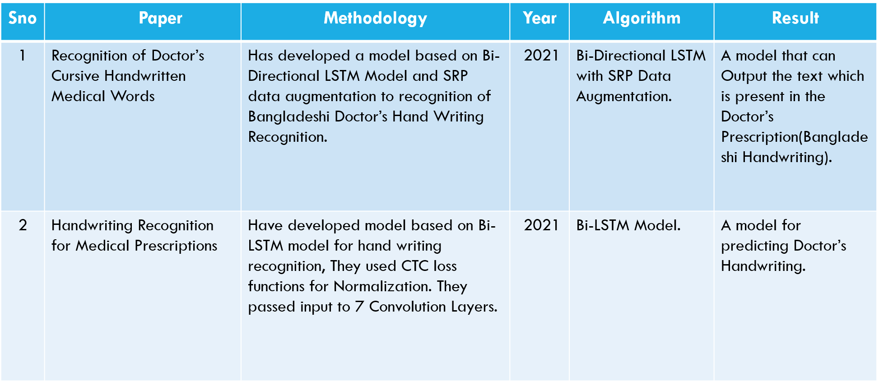  
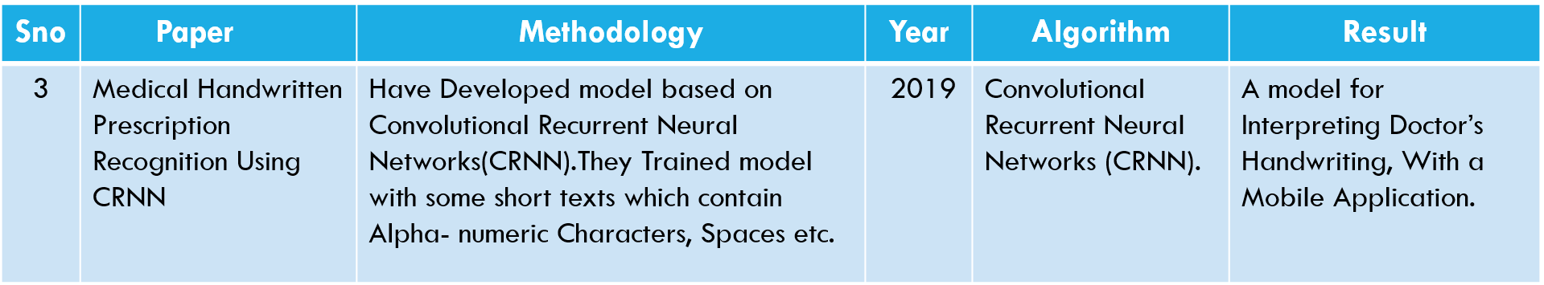

A new model with some added layers can be developed to get better accuracy and an Api can be made to connect model with application.

**CHAPTER 3. PROPOSED METHODOLOGY**

**3.1 DESIGN METHODOLOGY**

* Data collection: Importing Dataset from git repository (IAM dataset)
* Importing all required Deep learning related python libraries like TensorFlow, Keras, Matplotlib, Numpy, CV2.
* Read the metadata txt file and store the words with “ok” into new array. And then splitting the dataset into 3 parts i.e Training, Validation, testing samples with ratios (70:15:15 & 80:10:10 & 90:5:5)
* Find maximum length and the size of the vocabulary in the training data. Then build character vocabulary.
* Resizing the images without distortion in a rectangular size.
* Set image width to 128, height to 32, Batch size to 64 and padding to 99.
* Code for pre-processing image, Vectorizing image labels, process image labels and for prepare dataset.
* Build model starting with an input layer and next convolution base add convolution layer with different filter size (1024,512,128,64,32)
* Add 2 pooling layers after every 2 convolution layers. Its recommended to use Relu Activation function for Convolution Layers.
* Set Optimizer to “Adam” and then build the model.
* Now add Evaluation metrics, validation images and validation labels. And then create a callbacks to monitor the edit distances.
* Now, build the model and then set epoch value and fit model. And train the model.
* Now take images from testing set and pass them to input layer and predict them. Then, we can get output of predicted text by model.
* Now plot a graph for Value loss function Loss and Validation Loss Vs Number of Epochs.

**3.2 SYSTEM ARCHITECTURE DIAGRAM**

The Architecture diagram of our work is displayed in following figure

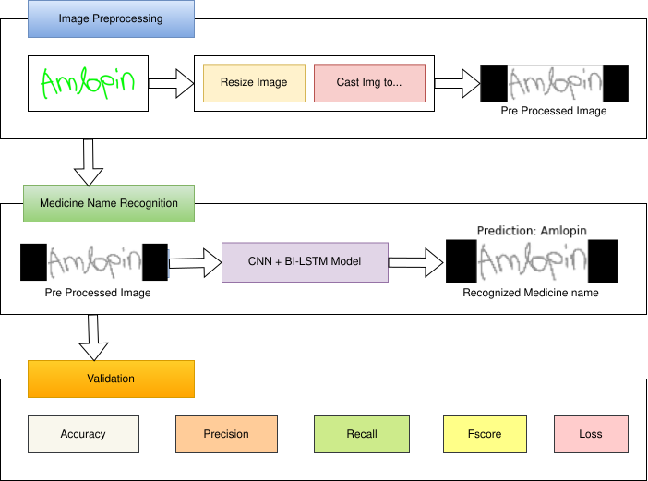

**Figure 3.2** Architecture Diagram for Doctor’s Handwriting Recognition**.**

Fig 3.2 describes the architecture of our work. The cropped image of doctor’s prescription is Fed as input to the model. Then we preprocess image with respect to our layers which we are using in model.

**3.2.1 RESIZE IMAGE**

In this Resizing Image Process, the image size gets resized to image sizes which we have

fixed that is image width to 128 and image height to 32 and also set padding to 99. We created a function to perform this Image Resizing.

**3.2.2 CAST IMAGE TO FLOAT32**

We do image resizing and cast image to float 32. In order to get floating point output values we are converting ‘uint’ to ‘float32’ so there will be no loss of precision.

The below figure demonstrates how the preprocessing is done and how the pre processed image looks like:

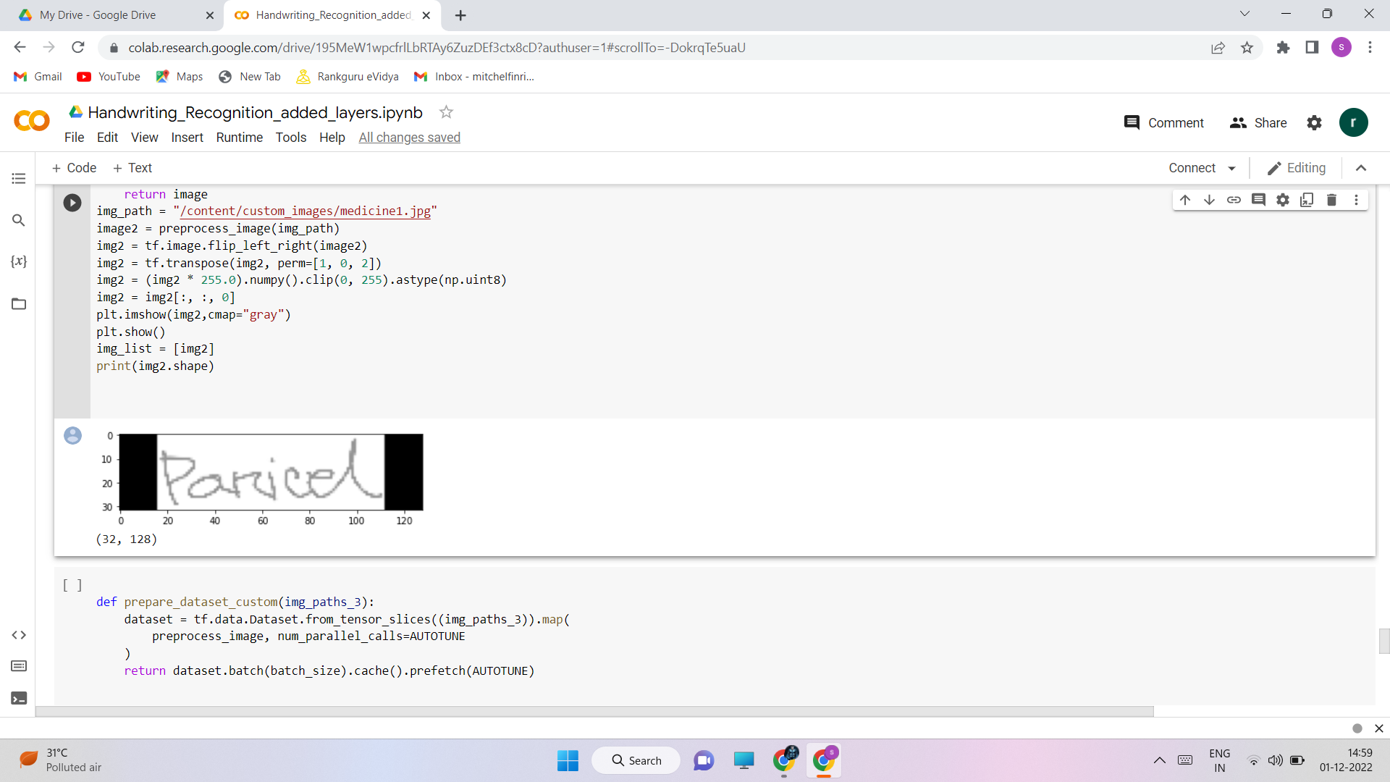

Fig 3.3 Distortion Free Image Preprocessing

**3.2.3 CNN + BI-LSTM MODEL**

In this project utilized cropped photos from the IAM Dataset and a few medical datasets in conjunction with our model to train. The training dataset, validation dataset, and testing datasets have been divided in a ratio of 90:5:5. The network has a sophisticated design that includes seven convolutional layers, optional batch Normalization layers, Max Pooling layers, Relu activation functions, a Bi-directional LSTM layer, and a CTC layer.

The procedure increases the number of channels in the first convolution layer from 1 to 64. which, after several layers, is raised to 128. There will be a Max pooling layer with RELU Activation function after each layer. In order to improve the model's ability to predict the outcome, we can add extra convolution and pooling layers. Additionally, adding additional parameters will improve accuracy and allow for a much reduction in loss.

The Bidirectional LSTM layer aids in the decoding of the convolution layer-generated features. We will next create a layer for label input for the appropriate photos, followed by a thick layer. To find the CTC loss, the last layer would be the CTC layer (Connectionist temporal classification).

The next step is to determine the callback distance. During this stage, ctc decoding will be done using predictions. Then, using tf.sparse.from dense and dtype as an int64, sparse the predictions made from dense. Identify a point when an increase in epoch values leads to a rise in loss value and the model will no longer improve performance at which point training may be stopped. Next, build the model and train it with various rising epoch values, setting checkpoints as necessary. We can use the count variable to determine the model's accuracy by passing some data as input, checking the total number of correct predictions, and calculating the percentage of right predictions. Accuracy, Precision, Recall, and F-score are all available.

The accuracy will be proportional to the initial weights we are establishing in the input layer. Setting appropriate starting weight values for the input layer and subsequent layers, as well as choosing an appropriate activation function, are required. Relu inside a convolution layer and Dense layer are typically utilized as activation functions for models like CNN and LSTMs. Typically, the terms "Relu" and "Sigmoid" can be used to convolutional layers. However, the Relu activation function is favoured. This allowed us to successfully construct our model.

**3.2.4 VALIDATION:**

The performance of our model is assessed using the validation metrics. The proportion of photographs that are correctly categorised indicates how accurate the outcome is. The percentage of tuples where the model's projected right text really occurred will be the model's precision. How many tuples the model accurately predicted is measured by the recall. The harmonic mean of Precision and Recall is the F-Score.

* 1. **DESCRIPTION OF ALGORITHMS**

Mathematical notations of algorithms:

* The propagations are applied two times, one propagation for forward cells and another for backward cells.
* Forward and Backward Activations would be considered and we can calculate Output

, ] + (1)

Equation 1: Mathematical Notation of Bi-LSTM Model

From equation 1, The represents the output and represents the output at time t. The represents the hidden layer function. denotes the hidden layer weights matrix. And similarly denotes hidden layer vector for bias values.gives the forward hidden sequence at time t and gives the backward hidden sequence at time t. As we are employing Bi-directional layers, we can have two directional sequences. Here, the iterations are done on forward and backward sequences and then the output layer will get updated.

The Mathematical Notation of Bi-Directional GRU as follows:

(2)

Equation 2: Mathematical Notation of Bi-GRU Model.

Similar to Bi-Directional LSTM, the Bi-Directional GRU also allows data sequence in two directions forward and backward. From the Equation 2, is a GRU function that denotes the data sequence flow in Forward direction and is a GRU function that denotes the data sequence flow in Backward direction. is vector concatenation operator for and Data sequence flows.denotes forward GRU’s state and denotes backward GRU’s state. denotes input vector.denotes output of cell at time t. By performing concatenation between forward and backward GRU states gives the output .

**Structure of Bi-Directional LSTM Model:**

The following figure shows the structure of Bi-Directional LSTM Model.

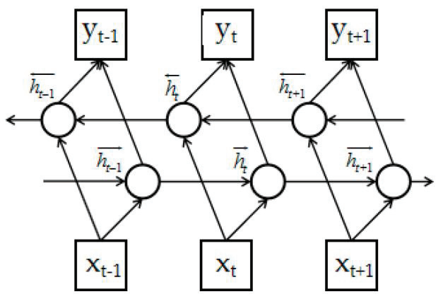

Fig 3.4 Structure of Bi-LSTM Model

**3.4 DESCRIPTION OF DATASET, REQUIREMENT SPECIFICATION**

Dataset we used is IAM Dataset which contains words images of different people with different writing styles and fonts. The images present in dataset are below

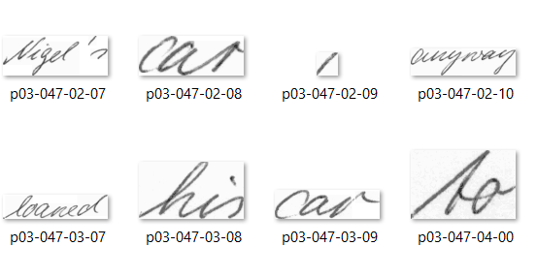

Fig:3.5 Images present in dataset

**Doctors hand writing dataset:** <https://github.com/rizwanrockzz/epics/tree/main/dataset>

**IAM hand writing dataset:** https://git.io/J0fjL

**Recommended Specifications:** PC or Laptop with minimum 8gb ram and supports GPU.

**CHAPTER 4. RESULTS AND OBSERVATIONS**

**4.1 RESULT ANALYSIS**

This chapter consists of results and observations obtained by execution of the project. We usually get some accuracy when we train our model. And then after adding one hidden layer example to extract more features if we want to add an extra convolution layer, we changed layers added a extra convolution layer and the accuracy for improved with lesser number of epochs. We trained our model with different quantities of training dataset and each at different epoch values. As the training data is increasing, the accuracy of model is getting increased or gain percentage getting increased. We passed two medicine names to model in form of an array and it predicted the output. By observing the outputs, we can conclude that the amount of training data and number of epochs decides the output (prediction) and also the initial weights we give to input layer, further hidden layers and the output layer.

**4.2 TEST CASE RESULT**

The following figure shows the Accuracy obtained for Bi-Directional LSTM Model.

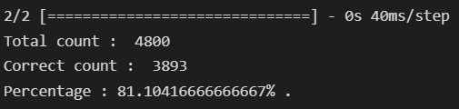

Fig: 4.1 Accuracy obtained for Bi-LSTM

From Fig(4.1) The accuracy obtained for Bi-LSTM is 81%. The Accuracy obtained for Bi-Directional GRU is displayed in below figure.

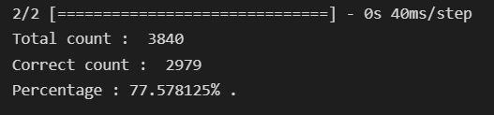

Fig: 4.2 Accuracy obtained for Bi-GRU

The below is the graph plotted between Losses vs Epochs (Training loss and Validation loss vs Number of epochs) for Bi-LSTM Model.

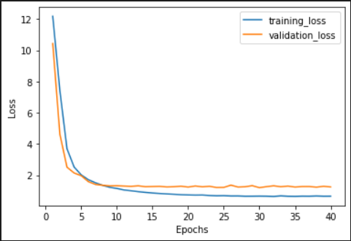

Fig: 4.3 Losses vs Epochs for Bi-LSTM

The below is the graph plotted between Losses vs Epochs for Bi-GRU Model:

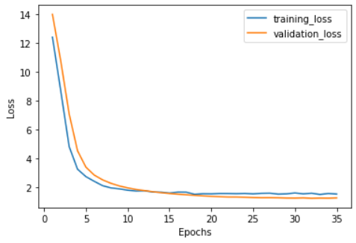

Fig: 4.4 Losses vs Epochs for Bi-GRU

Its clear that when Number of epochs is high the Loss Values of both Training Loss and Validation Loss is getting Reduced. When compared Bi-LSTM with Bi-GRU the LSTM is performing well the Training loss value is 0.6 and validation loss is 1.2.

Below figure demonstrates our outputs produced by model after giving custom image paths:

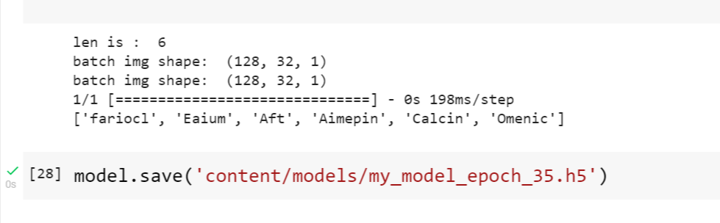

Fig: 4.5 Output of images in form of text.

The letters present in each word gets changed with respect to epoch we set during training. Quality and Size of the training dataset can also lead to best and accurate output of Text that is present inside an image.

**4.3 OBSERVATION FROM THE WORK**

The following table shows Ratio and Highest Accuracy recorded Epoch for Bi-LSTM.

Table: 4.1 Ratios and Highest Accuracy recorded Epoch

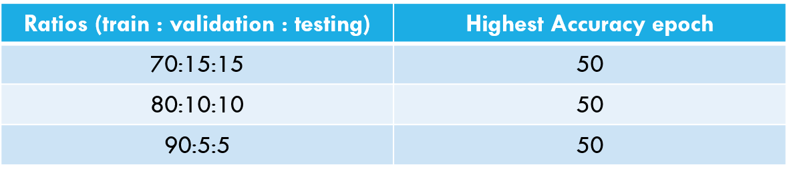

The below table shows Epoch count and Accuracy of corresponding epoch when the 90:5:5 Dataset Ratio is taken and done with Bi-LSTM.

Table: 4.2 90:5:5 Dataset Ratio-Accuracy

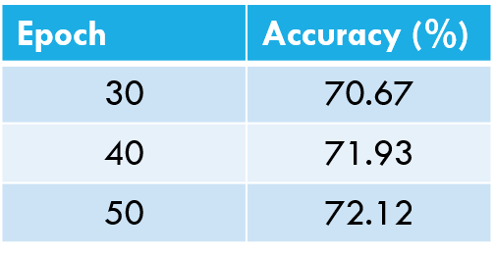

**Metrics:**

**Accuracy:** 0.72

**Precision:** 0.95

**Recall:** 0.728

**F-Score:** 0.824

These are results of metrics we opted and obtained. Here, the model was trained upto 50 epochs and got different accuracy values at different epochs.

The below figure shows old network topology and layers.

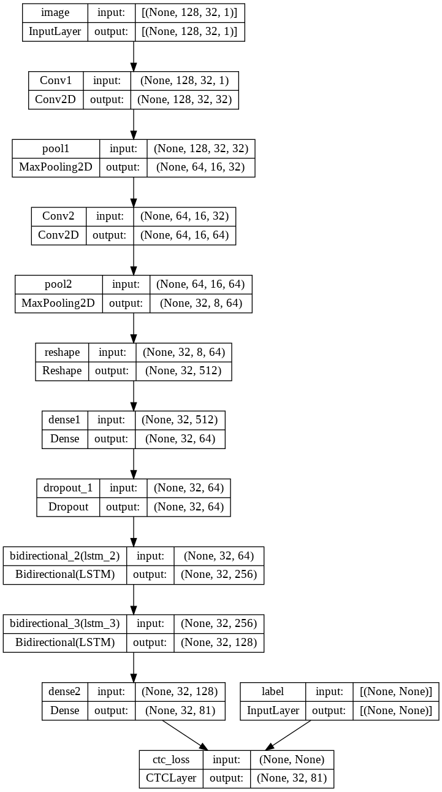

Fig: 4.6 Initial Network Topology with Bi-LSTM

We have added 3 more convolution layers and 2 Bi-Directional LSTM layers. The filters in 3 convolutional layers are of sizes 128,256 and 1024 respectively and in Bi-LSTM layer number of hidden units is 1024,512 respectively. We can clearly see the accuracy of model was increased by 8% and training is done with 25 epochs and finally by changing topology we got accuracy increased to 80%.

The below table demonstrates the Accuracies obtained at different Epochs for Both Bi-Directional LSTM and Bi-GRU Models.

Table 4.3 Accuracies for Bi-LSTM & Bi-GRU

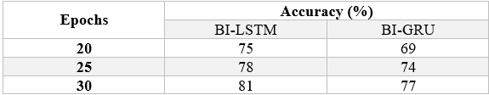

It is observed that at Epoch 30 the Accuracy of Bi-LSTM is 81% and Bi-GRU is 77%. It is clear that for large sized datasets Bi-LSTM is suitable and gives more performance than Bi-GRU. The quality of Dataset is very important and the dataset should contain more font styles of more people so that model can predict the text more accurately.

**CHAPTER 5. CONCLUSION AND FUTURE WORK**

**5.1 CONCLUSION**

This model helps Pharmacists and normal people to recognize the medicine name accurately which is present in the Doctor’s Handwritten Prescription. This effectively offers text in all handwriting typefaces. The feature extraction is carried out by Convolutional Neural Networks with many layers, and the decoding of the extracted features into English letters is assisted by Bi-LSTMs.We employ CTC to circumvent the fact that the true alignment between the input and the output is unknown. To accurately identify language specific to prescriptions provided by the doctors, more bias is applied to words that are present in a manually produced corpus. The accuracy can be maximised by increasing the size of the training data.

**5.2 FUTURE WORK**

The Accuracy for this model can be further improved by training with more handwritten prescriptions. Further an API can be created for this model which can be useful Mobile Applications or web application to use this model for Recognizing text from Prescription or from input of cropped Medicine Name. And more layers can be added by keeping complexity of model in mind. Training same dataset with new and Advanced Deep Learning Algorithms or Advanced Neural Networks can even improve Accuracy.

**REFERENCES:**

**[1]** S. Tabassum et al., "Recognition of Doctors’ Cursive Handwritten Medical Words by using Bidirectional LSTM and SRP Data Augmentation," 2021 IEEE Technology & Engineering Management Conference - Europe (TEMSCON-EUR), 2021, pp. 1-6, doi: 10.1109/TEMSCON-EUR52034.2021.9488622.

**[2]** S. Tabassum et al., "Recognition of Doctors’ Cursive Handwritten Medical Words by using Bidirectional LSTM and SRP Data Augmentation," 2021 IEEE Technology & Engineering Management Conference - Europe (TEMSCON-EUR), 2021, pp. 1-6, doi: 10.1109/TEMSCON-EUR52034.2021.9488622.

**[3]** L. J. Fajardo et al., "Doctor’s Cursive Handwriting Recognition System Using Deep Learning," 2019 IEEE 11th International Conference on Humanoid, Nanotechnology, Information Technology, Communication and Control, Environment, and Management ( HNICEM ), 2019, pp. 1-6, doi: 10.1109/HNICEM48295.2019.9073521.

